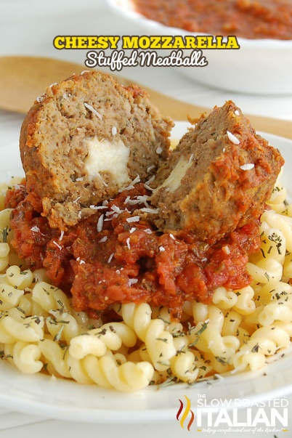
Mozzarella Stuffed Meatballs
Prep time 30 min Cook time 35 min
8 Servings
Ingredients
1 lb ground beef
¼ cup milk
2 tbsp tomato sauce
1 large egg, lightly beaten
½ cup Italian seasoned breadcrumbs
¼ cup Parmesan cheese, fresh grated
¼ cup Romano cheese, fresh grated
1 tsp garlic powder
½ tsp onion powder
½ tsp kosher salt
½ tbsp Italian seasoning
½ tbsp fresh rosemary, chopped finely
4 oz block mozzarella cheese, cut into 16 - 1/2" cubes
Directions
- Preheat oven to 400 degrees. Line 2 baking sheets with parchment paper or aluminum foil and set aside.
- In a large bowl, combine the milk, tomato sauce and egg. Then add the remaining ingredients except ground beef and mozzarella cheese. Mix well. Then add to the ground beef. Be sure not to overwork the meatballs. Working them too much can cause tough meatballs.
- Using a 4 tablespoon scoop, scoop out meat and place on a baking sheet or plate. After all meatballs have been scooped onto a tray, place mozzarella cube into each meatball. Then, with damp hands roll them into balls.
- Place meatballs on baking sheets, not touching. Bake for 35 minutes, rotating trays half way through cook time.
- Remove from oven and place meatballs into your sauce and allow to simmer for 30 minutes.
- Serve over pasta.

